Screenshot of java version
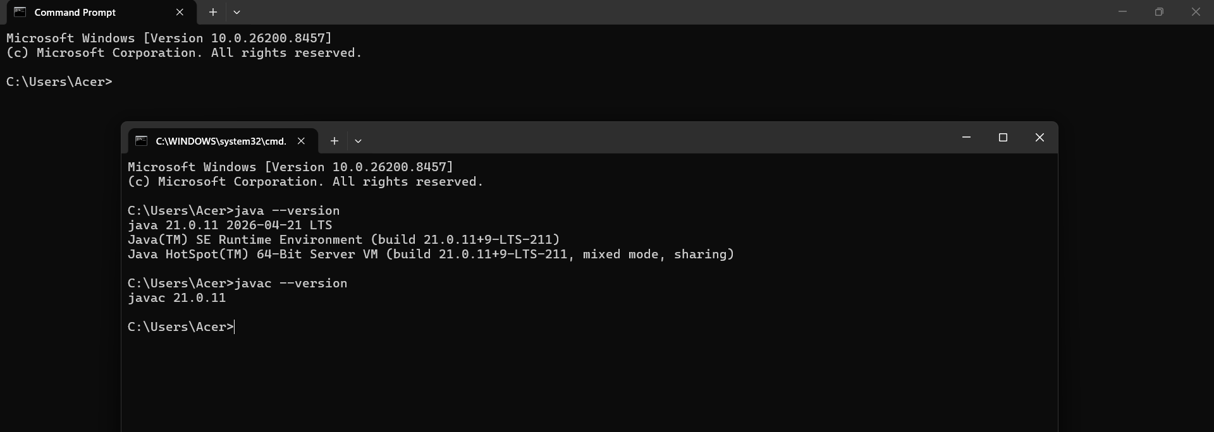

Screenshot 2: intellj open with java
